**Session 01**

* In redhat user name of admin is root.
* For doing something in OS you can use 2 options – interfaces – way.  
  1. GUI - Graphical User Interface  
  2. CLI - Command line Interface

🡪Every program has located somewhere. If you find this location you can read that code because linux is open source (You can open the code and read the code).

* Which firefox
  + /usr/bin/firefox
* Gedit – linux notepad – text editor
* Cd – change directory
* Ls – list all files and folder
* When you login to FB using login password, facebook send token known as cookie, if anyone got this cookie… and place in their system at same place… without asking login pass he can connect to your account. 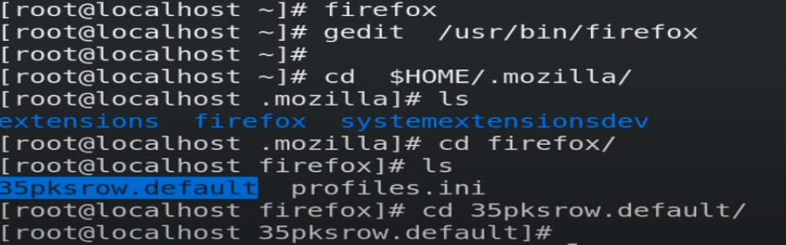
* Echo hi
* Espeak-ng hello
  + Text to Speak (TTS)

**Session 2**

* Watch -n 1 date  
  🡪Some commands runs infinite until we stop them.  
  🡪So we can not use terminal until its stop.
* There is 4 way to install your OS.  
  1. Bare-metal / Dual booting  
  2. Virtualization  
  3. Containerization   
  4. Cloud Computing   
  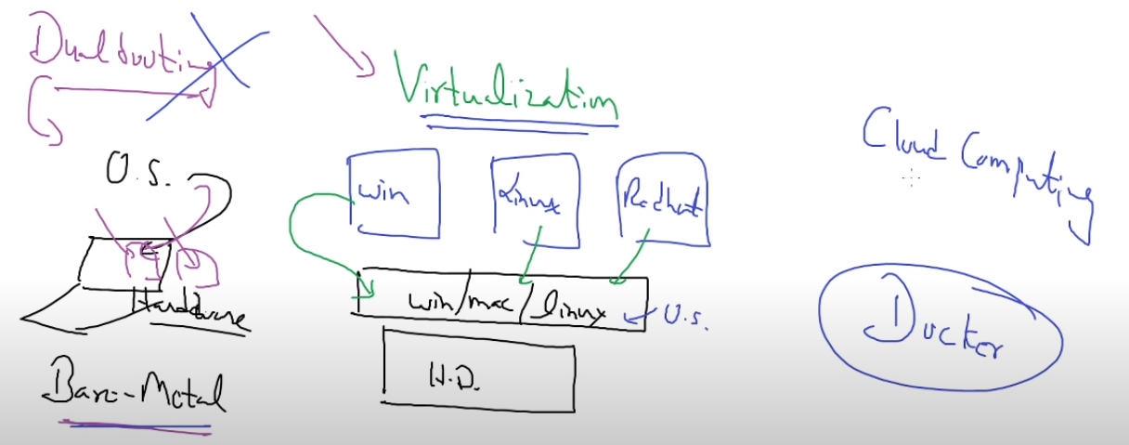
* Your program is running on the command prompt.
  + 90% say ctrl +z, some will also say ctrl+c but they don’t know difference between ctrl+c & ctrl+z.
* When you press ctrl +z program will stop but not terminate. It will pause your program and put in the background.
  + You can use jobs command to see background process-program.
  + fg <id> for start that is in background.
    - This is the one of the reasons, why computer consumes complete memory and they will format your computer.
* & - for run multiple programs at a time.
  + It is same as ctrl+z but it will put your program in bg in running state.

ECHO

* echo “date”
  + date
* echo “`date`”
  + inside `` it will work as a command.
* echo -n “hello”
  + It will remove space
* echo -e “hello\nhi”
  + echo -e “hello\b\bhi”
    - helhi
  + It will run escape sequence.
* Echo -n -e “hello\b”
  + It will remove new line and run escape sequence.
* Echo -n -e “ `date +%T` `sleep 1` \b\b\b\b\b\b\b\b”
  + Run this command inside a loop to see a proper output.

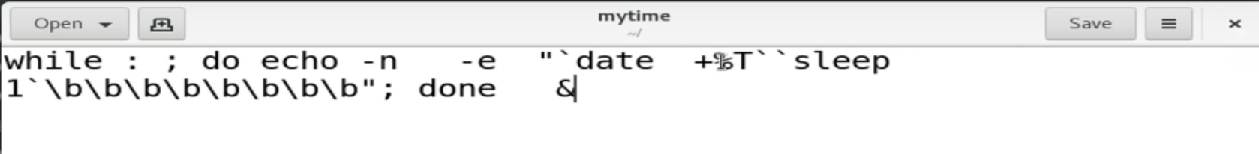

* + Run this file using bash.
* Man date
  + You can use this to read manual of any command.

Scripting language

* Simply write command inside one file and run using bash.
  + Gedit livedate
  + Bash livedate

**Session 03**

What things are required in networking?

1. Mobile / Android – Laptop / OS
2. Sim card – n/w, LAN, NIC, Ethernet (right term)
   1. You will give IP to our network card.
   2. N/W card name == Enp0s3
   3. Mb no == Ip Address
      1. We give ip to our N/w card.

We can use mobile number spoofing so we can have same number as another person have.

IP

* IP is always faster than hostname, it will not go to DNS.
* We have myth for IP, IP has four octets ranging from 0-255.
* IP history…
  + When IP term come in the world. It will look like 58978589.
  + One company has converted it into the four octets __. __ . __ . __ since remembering big number is harder.
    - This is very useful in many calculations and easy to remember.
    - So, every company start using this IP format – convention.
  + From childhood we are seen this IP format so they start believing this is the IP.
  + 192.168.1.12 In system first 192 converts into binary then. removed then 168 coverts to binary and so on.
  + 192*2^24 + 168*2^16 + 1*2^8 + 196 *12^0
    - 2899945412
    - Instead of four octet IP you can pass this, this is not blocked by any firewall. So, you can use this so you can access block sites.

Which IP is correct from following?

* All of the above.

Nslookup

* It will convert hostname into IP address.

BC

* Binary calculator
  + 192*2^24 + 168*2^16 + 1*2^8 + 196 *2^0
    - <https://2899945412>

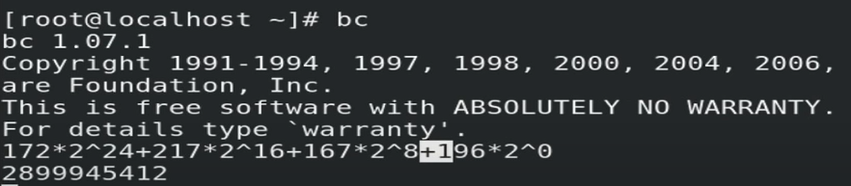

**Session 04**

* You cannot do many things if you don’t know behind the seen which program is running.
  + If you know which command is running there you can run many things.

Program – process

🡪 All the commands you have are somewhere available in the program, it is basically a program, But when you run a command then it will became a process.

Gnome-terminal

* It will launch terminal for you.

Ps-aux

* To see process running in the system.

Kill

* To stop – kill running process
  + Kill 1122

Touch

* To create empty file
  + Touch a.txt

Python

* Python prompt is repl/.
  + R- read
  + E- evaluate
  + P- print
  + L-loop
* Os.system(“date”)
  + To run date command or any other command inside python, for this you have to import os module.

Without using any command or program how we can create a file.

* > f.txt
  + This symbol will create a new file.
  + This symbol belongs to bash shell.
  + Behind the seen bash created this file.
* Bash > f.txt
  + This command runs.

**Session 05**

* Useradd jack
  + You can create new user.
* Useradd pal
* Passwd jack
  + Set password for jack user.
* Id jack
  + You can verify user is created or not.
* Rm /etc/passwd.lock
  + If you will not able to create a new user.
* Whoami
  + To see login from which user.
  + Echo $USER
  + Echo $SHELL

Multi User

* If you want to login to multiple account in parallel.
* Here you can login multiple users in a single go, without logout to other users.
  + It is known as console or terminal.
  + Windows provides only one screen or console.
  + For switching between a console.
    - Ctrl (left) + alt + f1
      * Behind Shortcut they will also run some commands.
      * Here chvt command used.
        + Chvt 5

In sudo this kind of command doesn’t work

So, in GUI this will not work.

* + - * Tty
        + To check in which terminal, you are.
        + If it is GUI terminal it shows /dev/pts/0.

Pts refers to sudo.

* + - * + If it is CLI it shows /dev/tty4.
      * 6 VT = 2 GUI + 4 CLI
      * GUI = f1 f2 (heavy)
      * CLI = f3-f6
        + Startx command will convert CLI into GUI.
    - This type of console is known as a Virtual terminal (VT).
  + For logout from terminal you can use exit or logout command.

How can you create more than 6 VT in rhel8?

* If you want to program do anything in the command prompt there would be some who will take your command, then find where is the program located and run this for you.
  + Shell will do these things.

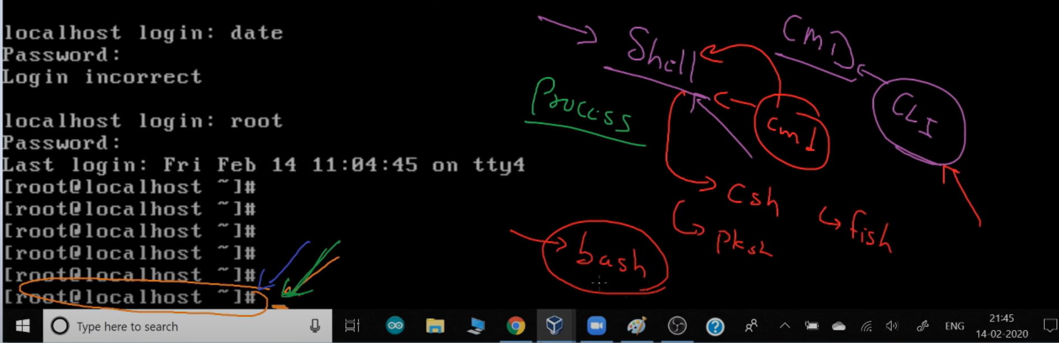

* + Without shell you cannot run command in command line.
  + Command prompt is also known as shell prompt.
    - Shell is a concept name.
    - In rhel 8 we are using bash shell.
* Maximum time most of security focusing on the OS. (Hacker perspective)
  + We want to login for getting shell of the OS.
  + If we somehow bypass this login and direct try to access shell, because shell has less security then we can try to break shell easily compare to login.
* Tput setaf 3
  + To change color of text.
* Reset
  + Will reset all shell values to default value.

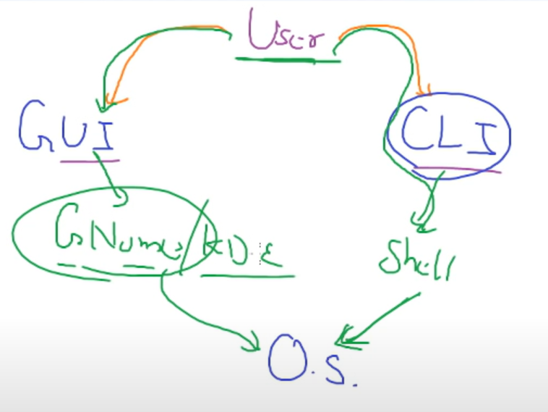

**Session 06**

* In python we have dynamic datatype
  + X = ”hello”
  + X= 5
    - It is known as type inference
  + X = ”True”
  + Type(x)
    - String
  + X= True
    - Boolean
    - First character should be Boolean.
* Python data types.

1. String
2. Number
   1. Int
   2. Float
   3. C (complex number)
3. List
4. Tuple
5. Bytes (In n/w world)
6. Bytearray (computer vision, image processing)
7. Dictionary
8. And lots more.

* Y= “Hello this is akshit”
  + Y[0]
    - ‘h’
  + Y[6:10]
    - ‘this’
    - :
      * It is known as slice operator
      * They will exclude last number.
  + Y[ : :2]
    - ‘hloti asi’
      * It will jump of 2
      * By default, jump is 1.
  + Y[ -1 : : 1]
    - ‘ l ’
  + Y[ -1 : : -1]
    - Print string in reverse order.
* In other language
  + “\n”
    - Process/parse
  + ‘\n’
    - Won’t parse
  + There is not a case in python language, “ “ == ‘ ‘
  + Print(“This is \t hi pop”)
    - This is hi pop
  + Print( r“This is \t hi pop”)
    - This is \t hi pop
    - It will not parse line and print raw line.

What is the name of the process who will process this line and then print this?

* This concept is known as interpolation.
* X = ” This is a Akshit”
  + “Akshit” in X
    - True

What is the difference between tuple and list?

* Tuple is immutable.
  + Read only
  + ()
* List is mutable.
  + Read and write
  + []
* Tuple
  + Tuple is read only
  + Once you create this you cannot change the element

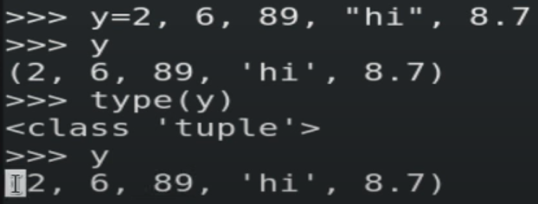

* + Tuple is immutable.

**Session 07**

**I/O Redirection**

How to get column wise data in list data types?

* List is not meant for column wise data.
* For this we have to use numpy data type.

I/O Redirection

* Date
  + Date > /dev/tty3
    - Internally tun this command.
  + Bash internally send output of date command – redirect output to the terminal.
    - They use > this symbol to send output to terminal tty3 or tty4.
  + Whenever you run any command, bash will run this command ans also run tty command to see which terminal you are in and send output to that screen.
* Date > /dev/tty5
  + It will send output of date command in the 5th terminal.
  + So without login you can see output in tty5.
* Date > ak.txt
  + Create a new file ak.txt and save date output here.
* EOL – Enter
* EOF – ctrl + D 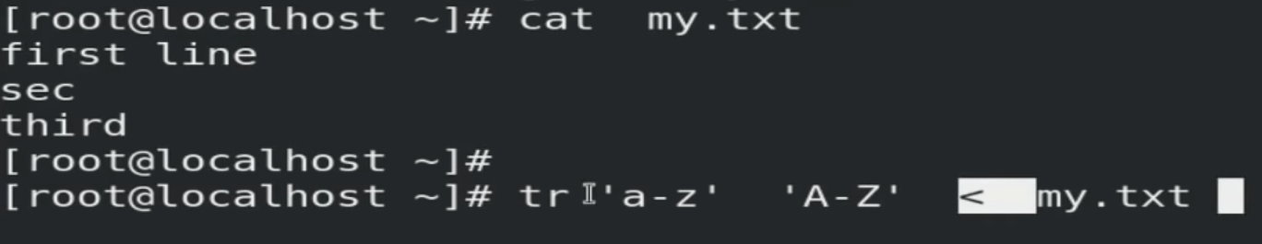
* <
  + This symbol go to file read the first line, go to tr, tr converts then go to second line and so on until EOF comes.
  + You can use this command to get input from any file

What is the right use of CAT command?

* Cat command need input.
  + If you will not give input it will open standard input.
  + Cat is just a command to print a string or other data as it is.
  + Cat my.txt
    - Behind the seen it will work as a cat < my.txt.
      * This < will give input to the cat command.
  + Cat my.txt > my1.txt
    - Bash shell (>) create a new file.
    - Now it will copy one by one line.
  + Cat > my1.txt
    - Here no one giving input so cat command opens standard input.

How to send your output to WhatsApp.

**Session 08**

**package management**

* What user can do inside OS?
  + File
    - Text/image/video
  + Folder
    - Dir/folder
* Most of files and folder are comes from installation software.
* Multiple files and folders and bunch in package and known as software.
  + So, software is also known as package.
  + When you install software, it will extract and copy in the folder of your OS.
* OS is a group of software’s or packages.
* Every OS different way to manage their package and different location.
* Rpm is used in redhat to manage softwares.
  + You can say rpm is software or command.

RPM

* + Install 🡪 copy
  + Uninstall 🡪 remove
* Rpm -q firefox
  + To query firefox software is installed or not.
* Rpm -q -a
  + To see all the software installed in the OS.
* Rpm -q -f /usr/bin/date
  + It will give you software name through this command comes in your system.
* Redhat supports .rpm extension.
* Rpm -e firefox
  + To uninstall software.
* Rpm -i -v -h firefox (press tab)
  + To install software.
  + Verbose mode. To see what they are doing in the background.
  + Hash – to see how much percentage is installed.
    - Rpm – command
    - -i -v -h – option, field, switch
    - Firefox – argument
* Rpm -q -l firefox
  + It will show you list of all the files and folder comes from this software.
* In graphical behind the seen double click use eog command.
  + You can use this and see graphical.
  + Eog path.

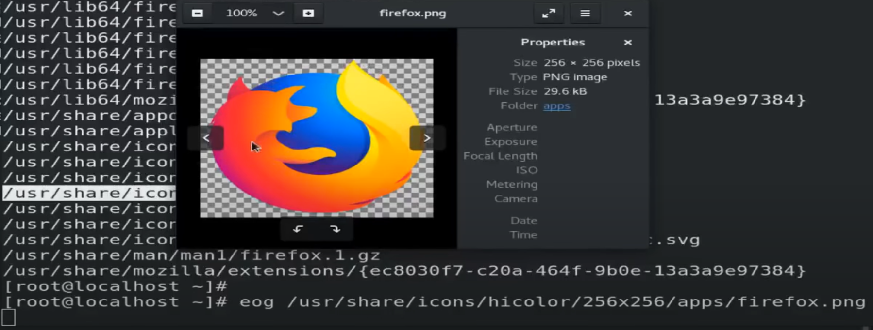

* Man rpm
* Rpm -q -i coreutils
  + It will show you information about the software and there you can find the link and using this you can see the source code of coreutils software.

**Session 09**

* In programming world
  + Function = method
  + Program file = module
  + Software = library
* Numpy datatype

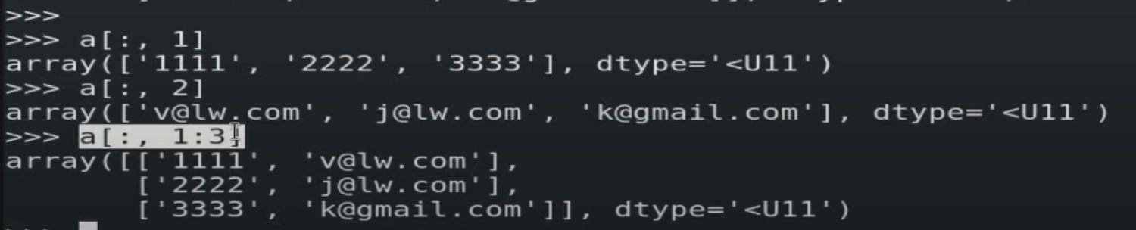

* + This thing is very useful in computer vision world.
* Cal
  + Echo $?
    - 0
    - It shows last typed command run successfully.
      * 0 – pass
      * Other – fail
* Xyz
  + Echo $?
    - 127
    - Failure

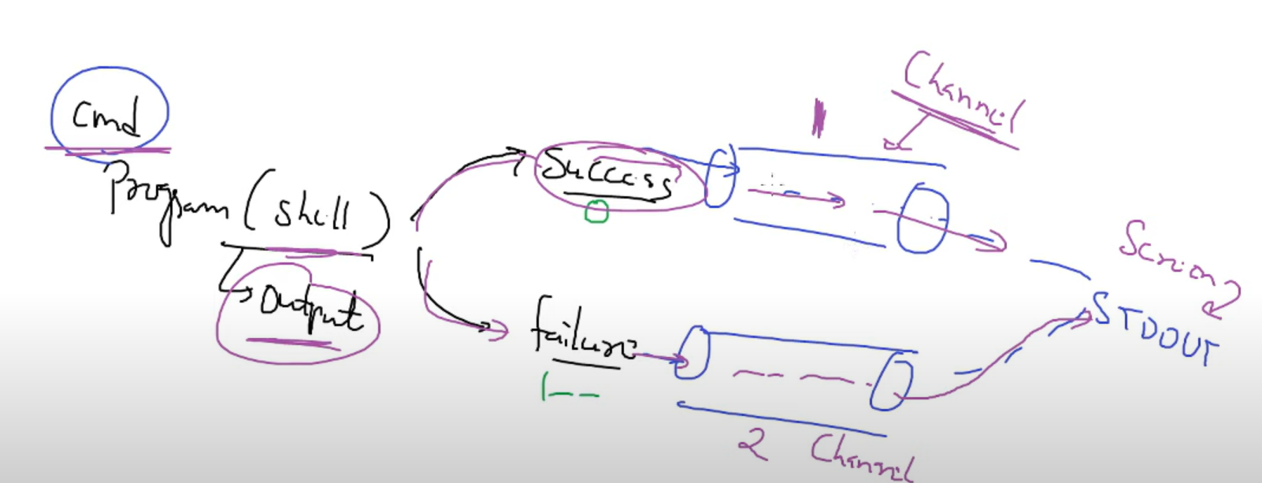

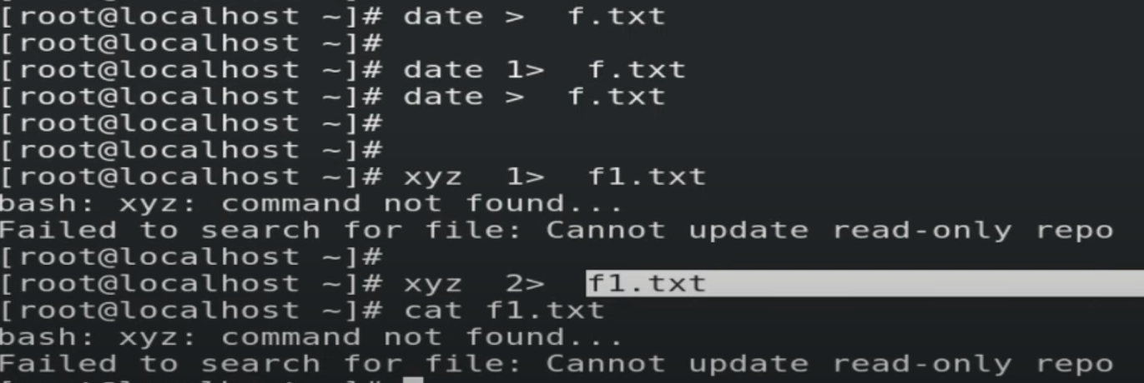

* Channel 1 – for success output.
* Channel 2 – for failure output.
  + By default, > here 1> used.
    - ‘>’ == ‘1> ‘
    - &> both 1> & 2>

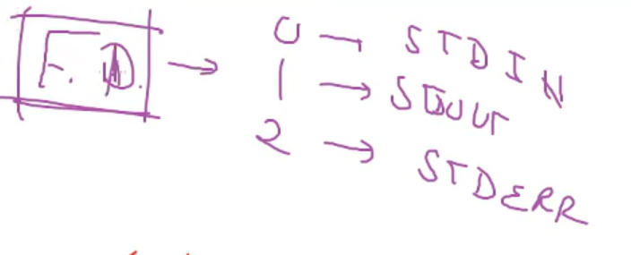

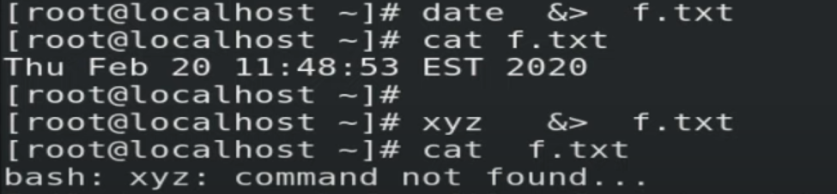

How we can send output to multiple location?

* Date | tee fz.txt
  + To send output to the multiple locations.

**Session 10**

**piping**

* Pipeline – it’s a pipeline of commands.
* Ls -F
  + It will show which are files and which are folder.
* Ls -l
  + It will show you all files and folder.
    - Starts with d are folders.
    - Starts with – are files.
  + Ls -l | grep -n ^d
    - Only search for those who starts with d.
    - -n will give you line number where this d is present.
  + Ls -l | grep -v ^d | wc -l
    - Give you those things who is not starts with d.
    - In this case it will give you all files

**Session 11**

* If you want to access anything you have two ways.

1. Local access
2. Remote access
   * Host
     + Computer we use in networking world.
   * Localhost
     + Run command in local laptop.

* If you want to access a shell using remote access, then you have to use secure shell.
  + For this SSH protocol is used.
* Prerequisite for network connectivity.

1. N/w physical
   1. Wire / wireless
2. IP address
3. Ping a->b, b ->a

* If you want to connect laptop from mobile.
  + You can use JuiceSSH.
* You have to connect to bridge.
  + So, vm also have his own network.

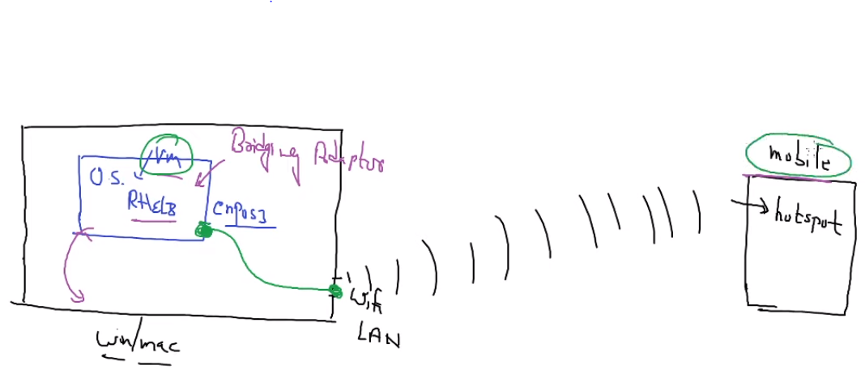

* + It will give you end to end connectivity.
* Route -n
  + It will give you gateway IP address.
  + Here mobile phone is working as a gateway for you.
* Cloning a VM.

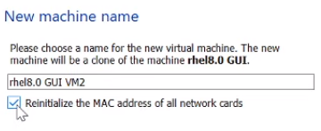

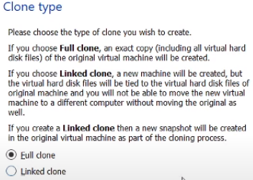

**Session 12**

* Bridge adaptor
  + Vm (mobile) can connect with each other.
  + They can also connect to internet.
  + Require hotspot or wifi – modem.
* Host only
  + Vm can connect to each other.
  + Vm can not connect to internet.
* Ssh [root@192.168.1.12](mailto:root@192.168.1.12) date
  + Date command run in that (IPAddress) system and return output to the remote location, from where you are accessing.
  + Here we can not use GUI based commands because no display available.
* Ssh -X 192.168.1.12 firefox
  + To launch GUI apps.
  + It will use ram of CPU of 192.16.1.12 and launch in your screen.
* Scp my.py 192.168.1.12:/root
  + To transfer file from one system to other system.
  + Upload file
* Scp -r 192.168.1.12:/root/fold1 /root/
  + To download from different system.
  + R for recursively, because we are transferring a folder.

**Session 13**

**Yum**

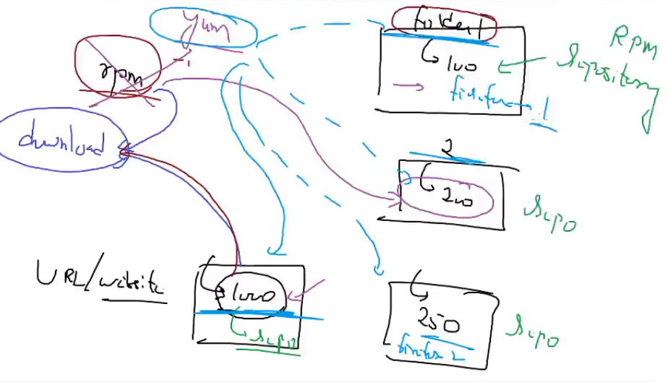

Why not to use RPM instead of yum?

* We have lots of files and folders, that contains URL of website where software located.
  + If we use RPM, first we have to manually download software and tell rpm to install this.
    - Many software comes with lots of dependencies. So, we have to solve all dependencies one by one. It will consume lots of time.
      * If software build on top of python then we need particular version of python installed. We have to download this then it will work.
      * Eg, VLC – it comes with 101 dependencies.
  + If we use YUM, yum automatically go to that site download and install for us.
    - It will go to all folders and search for URL’s.
    - It will also solve all dependencies and download it for us.
    - If different versions available of a particular software. Yum always install latest software.
  + VLC dependencies

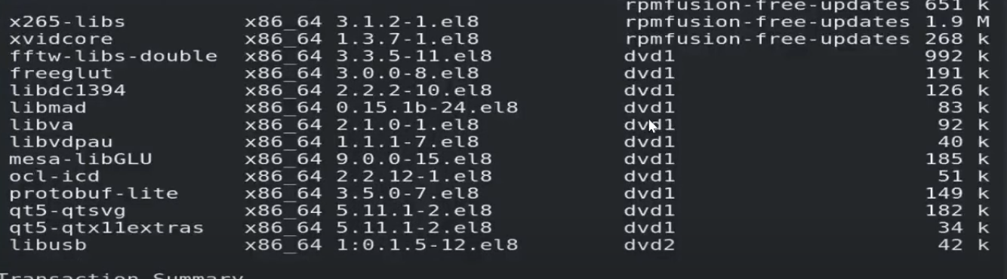 

* For using yum first time we have to configure yum.
* /etc/yum.repos.d/
  + This is the configuration file for yum.
    - You have to give one path to yum where to find softwares.
  + Now you can give any name to new file.
    - [dvd1]
    - baseurl=file:///dvd/AppStream/
    - gpgcheck=0
    - [dvd2]
    - baseurl=file:///dvd/BaseOS/
    - gpgcheck=0
    - [docker]
    - baseurl=https://download.docker.com/linux/centos/7/x86_64/stable/
    - gpgcheck=0
  + Here gpgcheck=0, disabling checking of signature key.
    - * Yum repolist
        + To check yum is properly configured or not.
      * Yum install <software_name>
      * Yum remove <software_name>
      * Yum list <software_name>
        + It will give you available software, if exist in your repo.
* In rhel8 we have one new command dnf (updated of yum).
  + Issues of yum

1. Heavy
2. Performance issues.
3. Break.
   1. If url does not exists, it will keep on running for some time.
      1. But dnf instantly stop and show us URL does not exist.
   * So instead of yum we can use dnf.

How to run VLC from root account?

**Questions**

* Without using any command or program how we can create a file?
* > f.txt
  + This symbol will create a new file.
  + This symbol belongs to bash shell.
  + Behind the seen bash created this file.
* Bash > f.txt
  + This command runs.
* How can you create more than 6 VT in rhel8?
* What is the name of the process who will process this line and then print this?
  + This concept is known as interpolation.
* What is the difference between tuple and list?
  + Tuple is immutable.
    - Read only
    - ()
  + List is mutable.
    - Read and write
    - []
  + Tuple
    - Tuple is read only
    - Once you create this you cannot change the element
* How to get column wise data in list data types?
  + List is not meant for column wise data.
  + For this we have to use numpy data type.
* What is the right use of CAT command?
  + Cat command need input.
    - If you will not give input it will open standard input.
    - Cat is just a command to print a string or other data as it is.
    - Cat my.txt
      * Behind the seen it will work as a cat < my.txt.
      * This < will give input to the cat command.
* How to send your output to WhatsApp.
* How we can send output to multiple location?
  + Date | tee fz.txt
    - To send output to the multiple locations.
* Why not to use RPM instead of yum?
  + We have lots of files and folders, that contains URL of website where software located.
    - If we use RPM, first we have to manually download software and tell rpm to install this.
      * Many software comes with lots of dependencies. So, we have to solve all dependencies one by one. It will consume lots of time.
        + If software build on top of python then we need particular version of python installed. We have to download this then it will work.
        + Eg, VLC – it comes with 101 dependencies.
    - If we use YUM, yum automatically go to that site download and install for us.
      * It will go to all folders and search for URL’s.
      * It will also solve all dependencies and download it for us.
      * If different versions available of a particular software. Yum always install latest software.
    - VLC dependencies
* How to run VLC from root account?